**[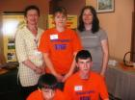](http://ss-prirodoslovna-ka.skole.hr/upload/ss-prirodoslovna-ka/album/31/large_img_193.jpg)**